Sales playbook Agfa Digital Radiology (draft)

Order Generation process
From the customer buy-in process to our CRM opportunity staging
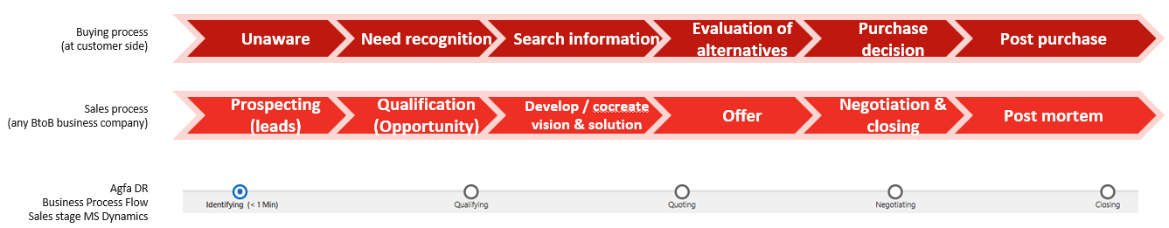
Sales Process  Agfa flow | Prospecting  Identifying | Qualification  Qualifying | Develop/cocreate  Quoting | Offer  Quoting | Negotiation Closing  Negotiating | Negotiation Closing  Closing | Post mortem  Closing
Why to step in | Customer express potential interest in our products / solutions | Our products / solutions address the customer need & the stakeholders are identified | A meaningful offer (configuration & price) is created | Internal requirements considered | Adjust the offer based on new expectations raised by the customer | Purchase order received (won) or notification of award to another vendor (lost) | Need to learn from this journey
Purpose | Understand/scope needs | Investigate whether it is worthwhile to make a proposal for the customer: move forward or stop. | Engage all stakeholders and build sales strategy | Send our best offer (offer + options) | Negotiate with customer (offer + options) | Obtain booking pack document signed | Capture learnings in CRM
Customer mindset | 1st level of engagement (willingness to share pain points, needs, start exploring options) | Customer explores solutions | Customer requests commercial proposal | Customer invests time to validate solution, gives feedback, shares positioning against competition | Customer reviews final proposal, agrees on T&Cs, questions about financing details | Customer understands offered solution and is ready to sign | Partnership strengthened.  Next steps set
Internal activities | Contact potential customers (phone, visit, letter...) & create a lead | Estimate effort to make proposal | Estimated close date & estimated order value should be known.  Review % DS, % DH, forecast category | Commercial proposal formally shared with customer (incl. options) | Create new version of the quote (co-build with customer and negotiate prices)  Review % DS, % DH, forecast category | Set opportunity as Won (Release quotation by creating the order in SAP) or Lost | Win/loss analysis
 | Qualify the lead (close or qualify)  BANT: Budget, Authority, Need, Timing | Competitors identification required before progressing to the next stage | Create a quote in Sofon (get support from internal experts) | Sofon quote status to be set as “sent” | Check final contractual document readiness | All required paperwork has been received & fully executed | Feedback to Marketing (tenders)
 | Create an opportunity Feasibility: Field value cannot be 0 or 10 before progressing to the next stage | % Deal Sign: assess Agfa preference  % Deal Happen: assess customer readiness (funding availability, project readiness & timing) | Perform site due diligence (rooms)  T&C to be aligned with customer |  |  | Organize hand-over meeting: final Order Package to be handed over to Order Fulfillment.
 |  | Define forecast category | CRM information (budget, products) is now driven by Sofon

Forecast Category
Definitions of DS % (Deal Sign) and DH % (Deal Happen)
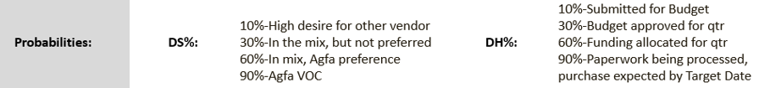
Calculation of % Feasibility (system automation)
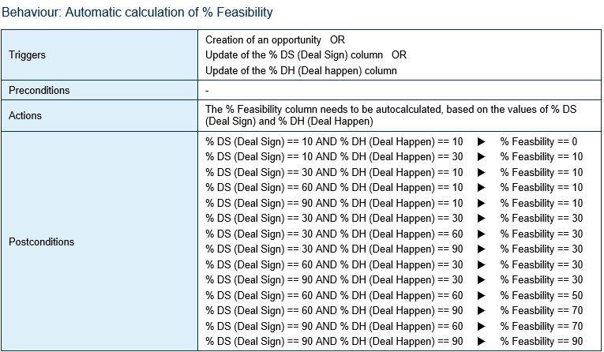

Forecast category / Feasibility %
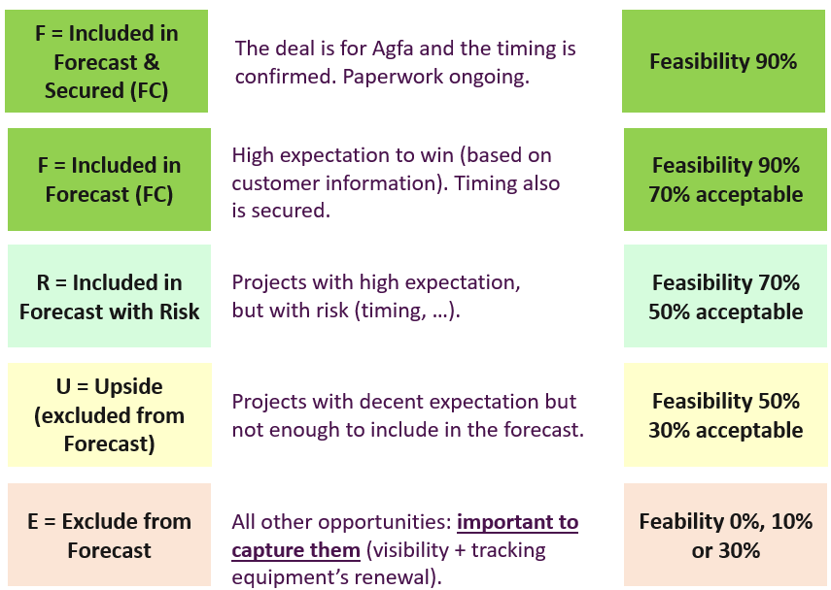
Order Intake Funnel Forecast
We use the field Forecast category to calculate the Order Intake Funnel Forecast which should always be aligned with the Financial Forecast.
The Forecast category is defined by the KAMs and Channel managers and revised on a weekly basis based on the customers insights. The Sales Managers and Sales Leaders are responsible to get reliable figures that fit with the business expectations (Order Intake targets).
Funnel Forecast is the sum of:
Won
+ Included and secured
+ Included
+ Included with Risk

Attention point:
The Upside funnel should always cover twice the Included with Risk funnel in order to mitigate the Risk
Upside > 2 * Included with Risk

Month 2 and month 3 of the quarter:
- The number of Included with Risk opportunities should be limited as much as possible (especially for the biggest ones). The customer should know if the deal is confirmed at the due time.
- The Upsides should also be moved to highest or lowest Forecast category (based on the choice to put efforts or not to put efforts on them)

Business reviews
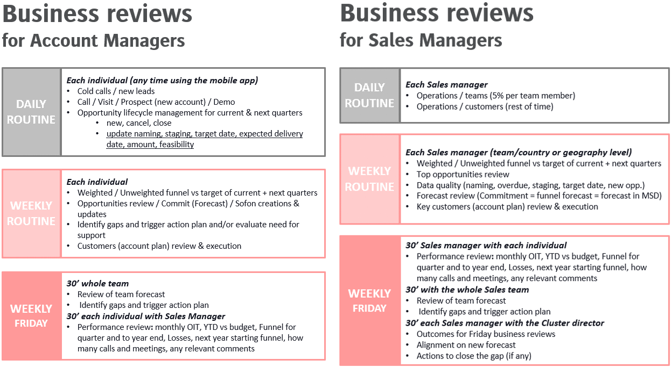

Weekly meeting with Sales manager (and/or Cluster leader) and each Channel manager & KAM
Preferably Friday morning / individual meeting = 30’ (each individual to update the funnel upfront)
- Individual OIT YTD performance vs target
- Current quarter funnel status = 10’ (by using the Sales manager view in MS Dynamics and by reviewing/updating each opened opportunity): review of all opened opportunities paying specific attention to:
- Topic: according to naming convention
- Estimated close date & staging & quote status
- Estimated delivery date: it is used to consider the Supply Chain forecast
- Planned revenue recognition date: it is used to calculate the Book & Bill Sales forecast
- % Deal Sign & % Deal Happen: evidences required (emails, notes, …) for the largest opportunities
- Forecast category: re-assess the commitment (initially triggered by % Feasibility)
- Opportunity margin: modality OIT margin target to be considered
- Next quarter funnel status = 10’ (open MS Dynamics and review and update each opened opportunity)

Outcome = individual commitment = FC funnel (=Won+Included+Included with Risk) and Status on actions to close the gap if any (new visit, new leads, new opps, new campaign)

Description field and timeline to be used in order to track actions and record notes.

Weekly meeting with Sales leader (cluster or country) and the whole Sales team
Preferably Friday afternoon / 30’ (one shot)
Current quarter funnel status:
- OIT actuals
- FC funnel = Won + Included & Secured + Included + Included with Risk
- Upside = How reliable are our Upsides? Do we have 2 times the Included with Risk?
- Main actions to close the gap to target if any
Next quarter funnel status
- FC funnel = Won + Included & Secured + Included + Included with Risk
- Upside = do we have 2 times the Included with Risk?
- Main actions to close the gap to target if any

Business Pulse
Cluster Sales & Services Leaders + Head of Region + Commercial Excellence (weekly or twice a month)
Data quality
OIT actuals + Funnel Forecast
OIT margin status
Large deals & Strategic deals identification
Sales (Revenues walk dashboard): Actuals + Expectations on Services contracts + Time & Materials + Order Book (Implementation + Equipment) + Book & Bill

Head of Regions + Finance + Commercial Excellence + DRS President (weekly, every Monday)
OIT actuals + Funnel Forecast
OIT margin status
Large deals & Strategic deals identification
Sales (Revenues walk dashboard): Actuals + Expectations on Services contracts + Time & Materials + Order Book (Implementation + Equipment) + Book & Bill

Monthly Performance Reviews (MPRs)
Standard agenda
- Financial performance (OIT, Sales, Reco, NWC)
  - Current quarter
  - Year To Date
  - Full Year
- Hi/Lowlights of the region
- Actions plan
- Current quarter OIT outlook (funnel based)
- Large deals Current & Next Quarters
- Order Book
- Inventory
- Current quarter Sales outlook
- Current quarter B&B expectations
- Channel excellence (Financial dashboard + strategy execution)
- Services Operations
- Services Strategy execution
- Services P&L
- Reco

Large deals & strategic deals
- Large deals:
- Purpose = to identify a specific winning strategy for a few large deals that would help to secure our OIT achievement
- Criteria = estimated order value (without SMA) & Period = next 6 months
- Threshold defined according to clusters/regions
- Platform for tracking progress: MPR

- Strategic deals:
The strategic deals are identified during the weekly regional business pulse meetings. The criteria is one of the below ones:
- Complex deals (bundle, multi-products…)
- Competition (need to Win)
- “First of a kind” deal (new product, new market, net new account)
- Ad hoc (small deal that could trigger larger deals)
A specific platform to be created to track progress on strategic deals

